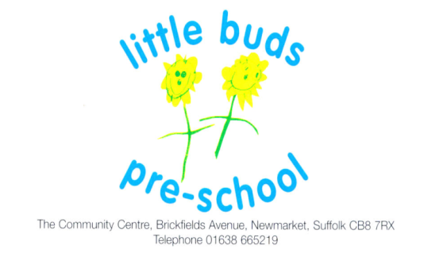
Term Dates 2022/2023

Autumn Term
Monday 5th September 2022 – Friday 21st October 2022
(Half Term – Monday 24th - Friday 28th October 2022)
Monday 31st October 2022 – Friday 16th December 2022

Spring Term
Friday 6th January 2023 – Friday 10th February 20232
(Half Term – Monday 13th – Friday 17th February 2023)
Monday 20th February 2023 – Friday 31st March 2023

Summer Term
Monday 17th April 2023 – Friday 26th May 2023
(Half Term – Monday 29th May 2023 – Friday 2nd June 2023)
Monday 5th June 2023 – Friday 21st July 2023

Registered Charity number 1019920
Supervisors Sandra Smith 01638 602189 & Sally George 01638 601049
http://www.littlebudspreschool.org

